1. 
2. Just like method can have **parameter**, class can have **type parameter**.
3. 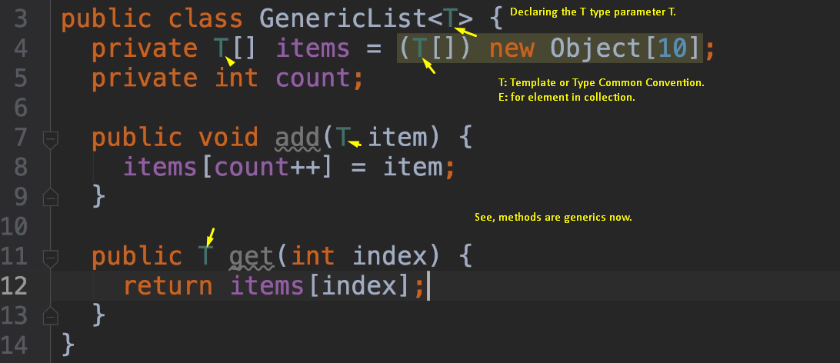
4. 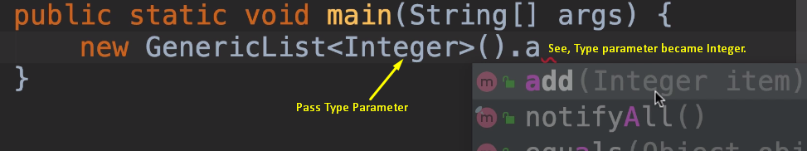
5. 
6. 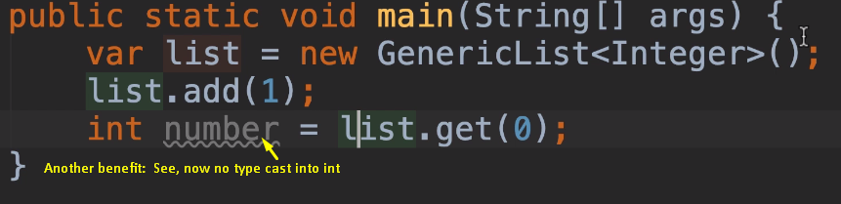
7. **Benefits**:
   1. No need to create different classes for different types.
   2. No need to type cast. So, code becomes cleaner.
   3. Now, you get compile time error when trying to store wrong type of item.